|  |  |  |  |  |  |
| --- | --- | --- | --- | --- | --- |
| Date | 28-Nov-22 | | | Tester Name | Mayuri Patel |
| Environment | Penfax - Test | | | Login used |  |
| Operating System | Windows | Version: | Update: | | |
| Software Used | Edge | Version: | Update: | | |
| Not Applicable | Version: | Update: | | |
| Release version | 22.4.1 | | | | |
| Title | Death | | | | |
| Test Type | Regression | | | | |
| Test Scenario | Process a death payout to a spouse in the form of a RRSP | | | | |
|  |  | | | | |
| Expected Results | Deceased member’s investment account should have $0 after death payout is processed.  Benefit Receipt should be generated under beneficiary’s account.  PEPP Payment Confirmation letter should be generated for beneficiary. | | | | |
| Pass/Fail | Pass | | | JIRA# | N/A |

Describe your steps with screenshots:

1. In PENFAX5 do a search for deferred survivor member. Click on the stakeholder ID.

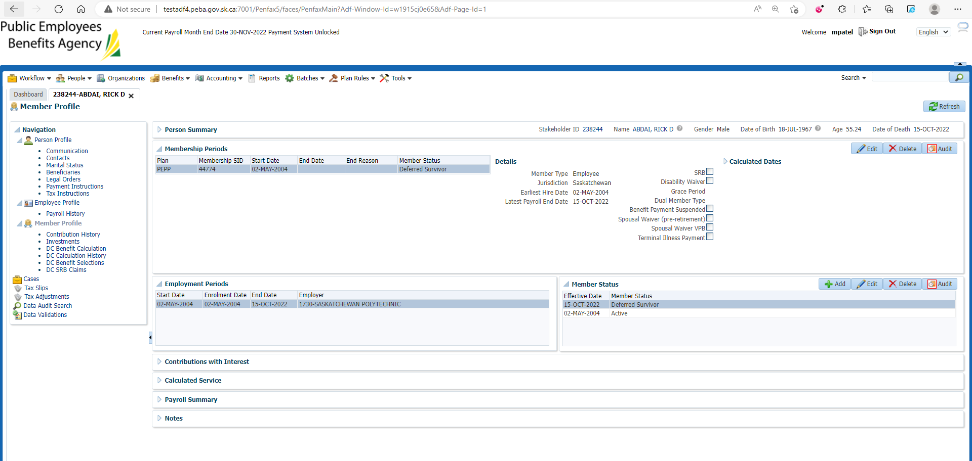

1. Click DC Benefit Selection. Click Add.

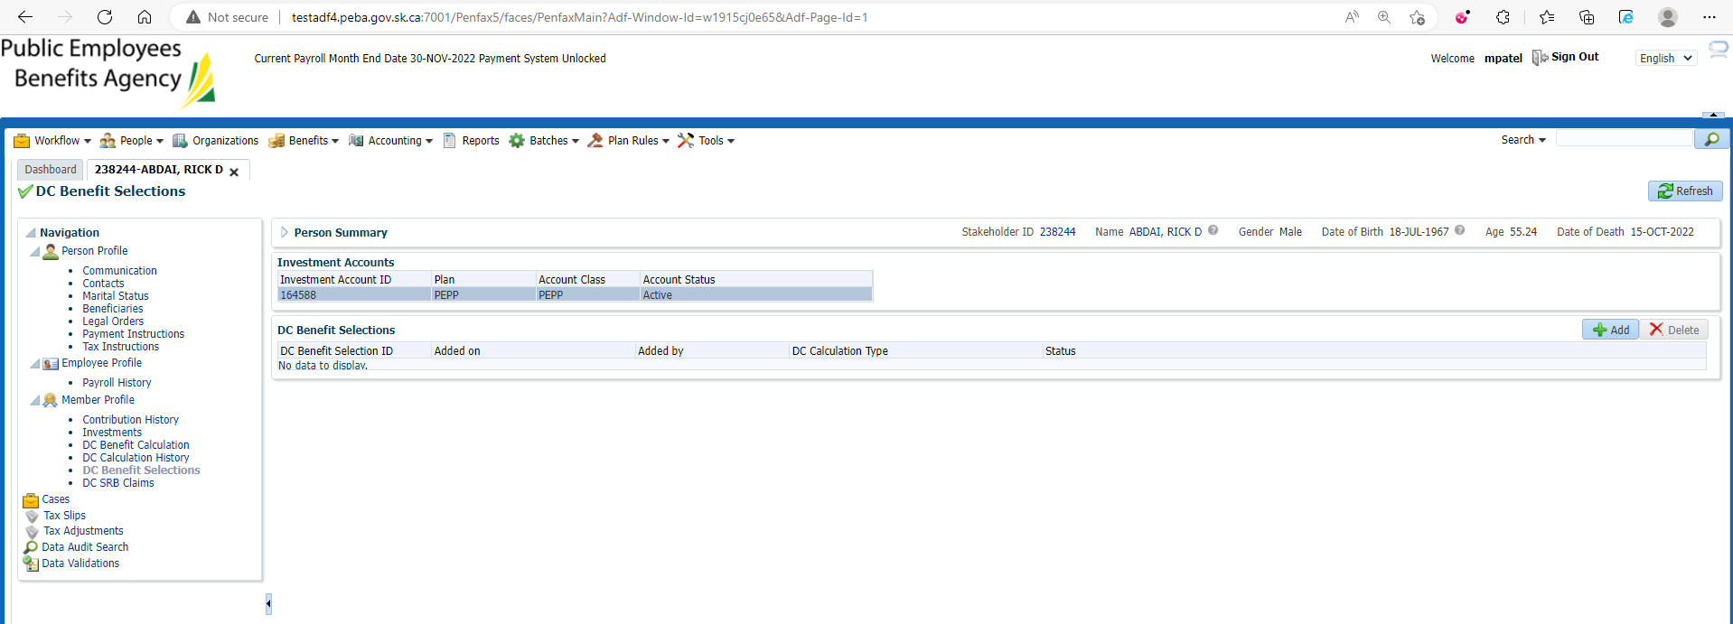

1. Make sure Date of Death is populated. Click Next.

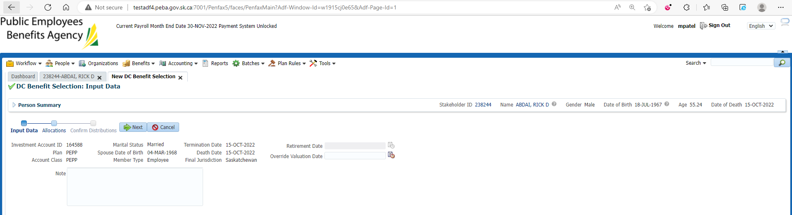

1. Under Allocation Click Add.

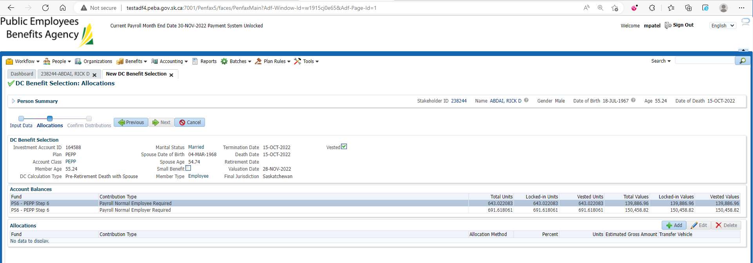

1. Select a fund from the dropdown. Select the contribution type. Change allocation method to Percent. Input 100%. Under transfer vehicle select RRSP. Click Save. You will need to repeat for each fund and each contribution type.

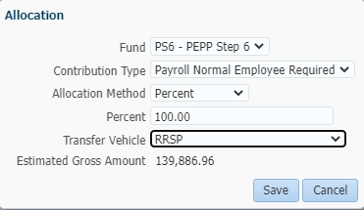

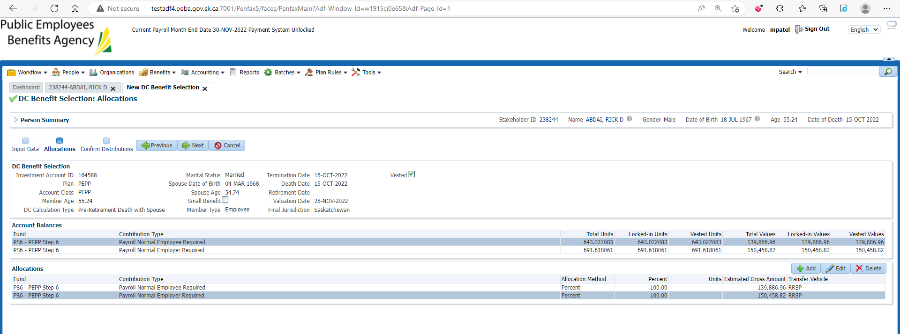

1. Click Next. Under Onetime amounts you will need to attach payment instructions. Need to payout to a financial institution. Under tax instructions add basic instructions. Click submit for approval.

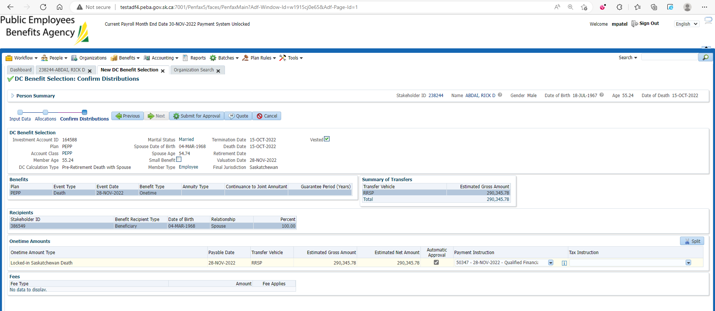

1. Approve the payment

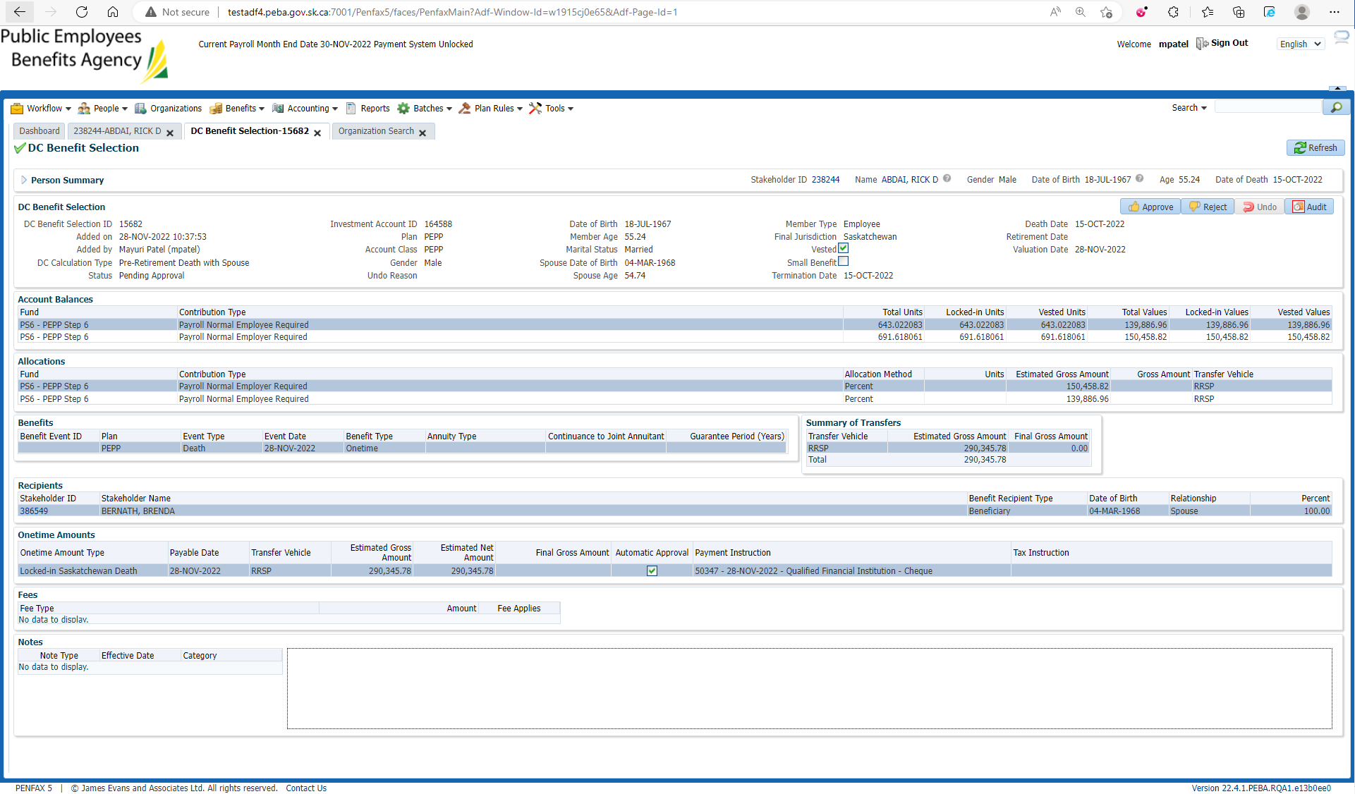

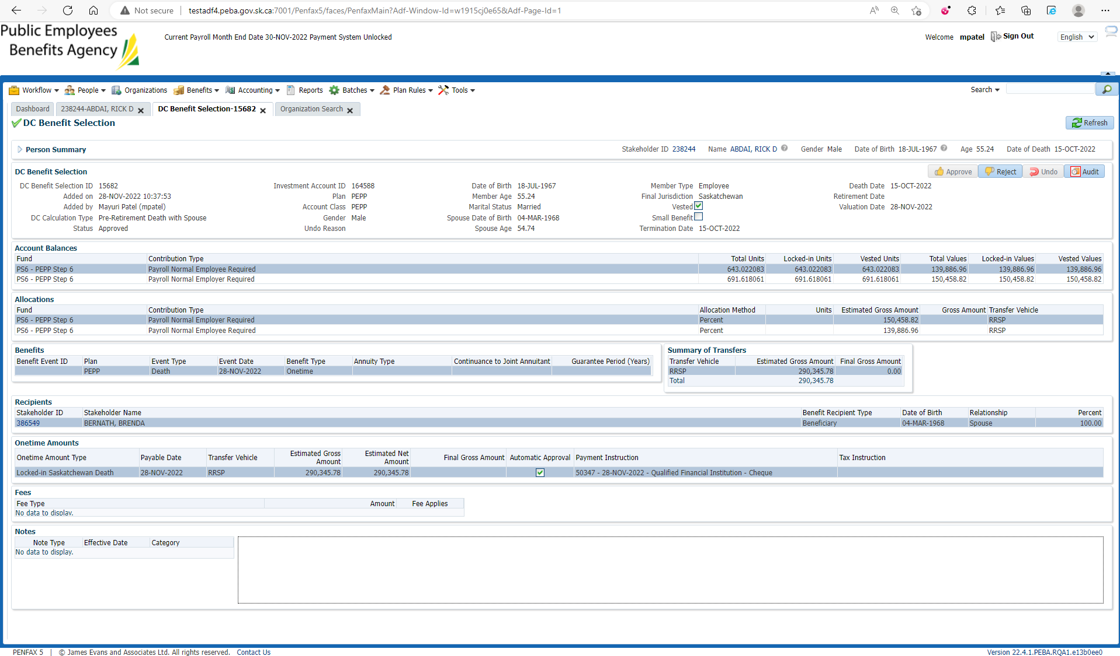

1. Approved Benefit Selection can be seen under Member Profile -> DC Benefit Selection in Penfax.

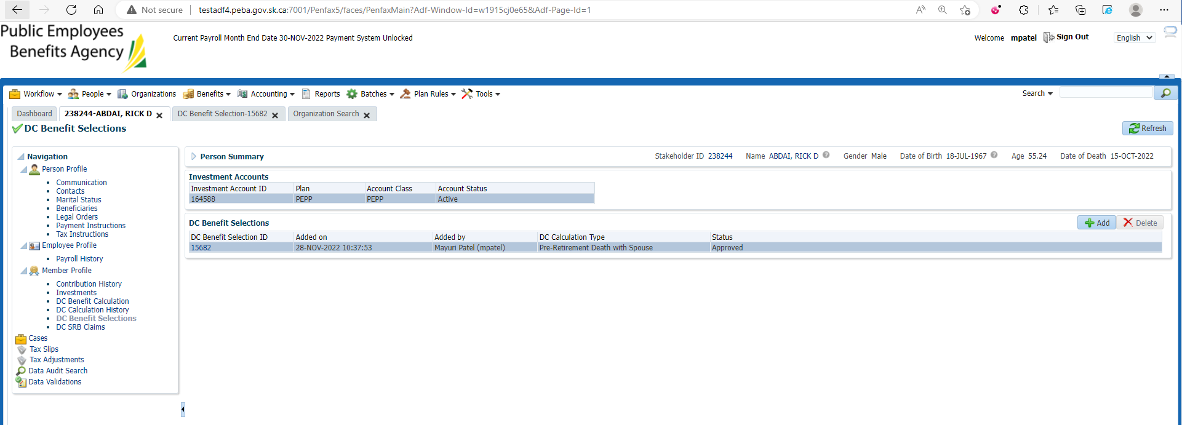

1. Wait for overnight batches to run.

Bring up the deceased member.

Click on Investments.

Make sure the account balance is now 0.

Make sure the account status is now inactive.

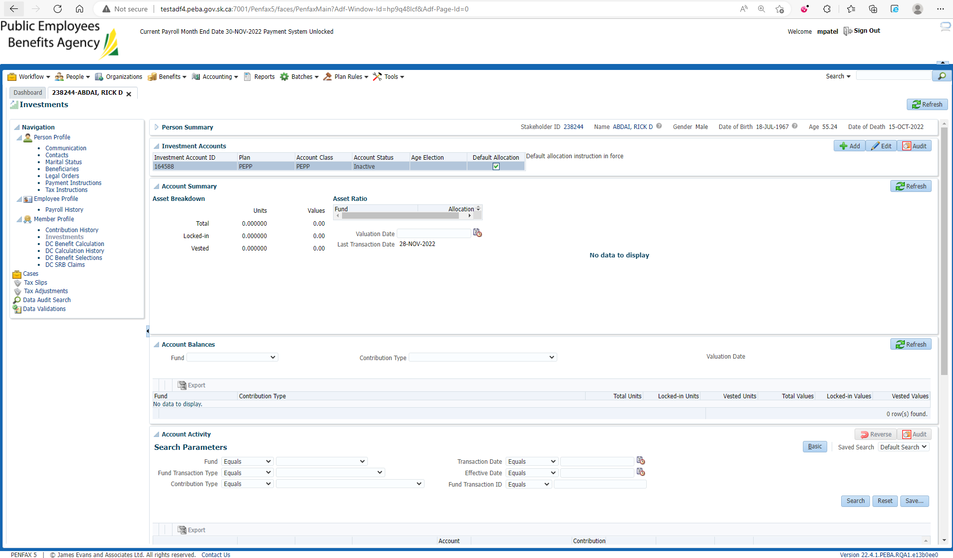

1. Go to the member profile. Make sure the member status is death.

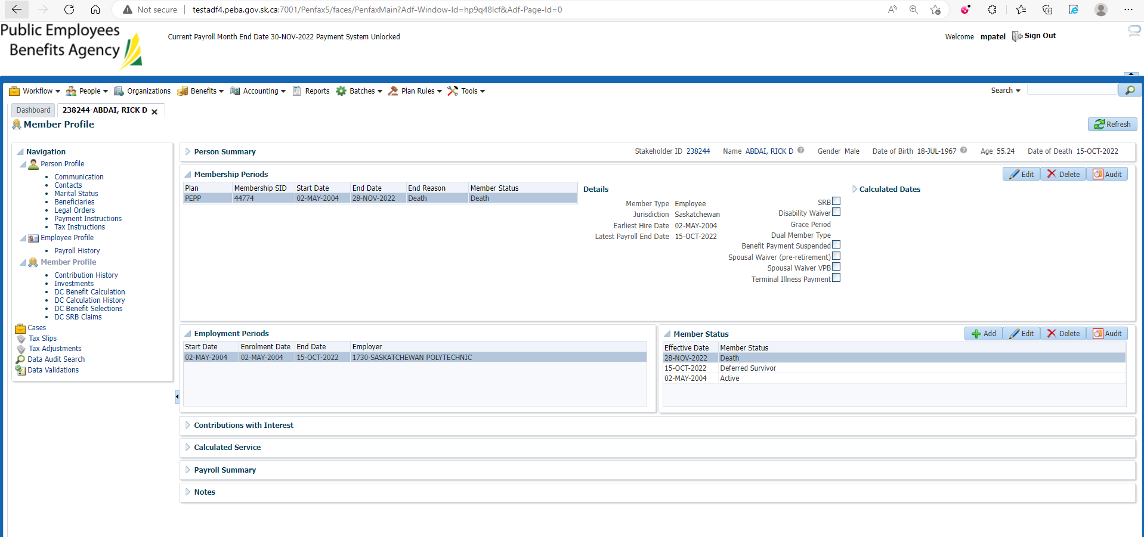

1. Bring up the Beneficiary stakeholder's account. Open the benefit recipient tab.

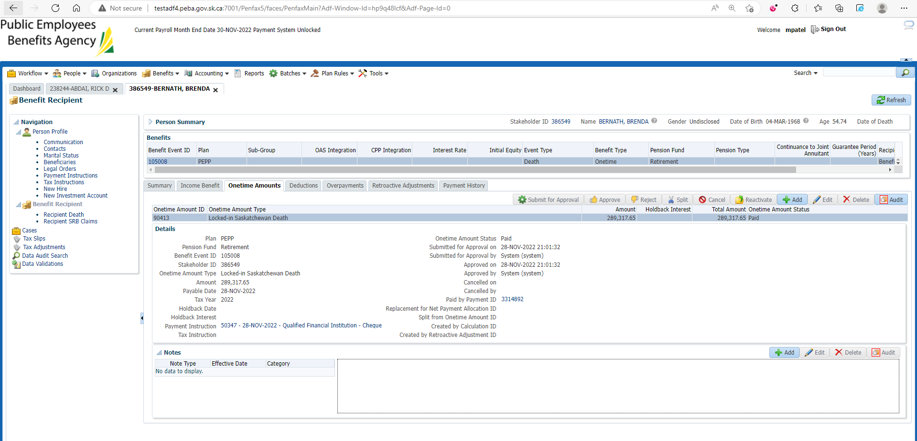

1. Go to Communication. PEPP Payment Confirmation Letter should be generated under Outbound Documents.

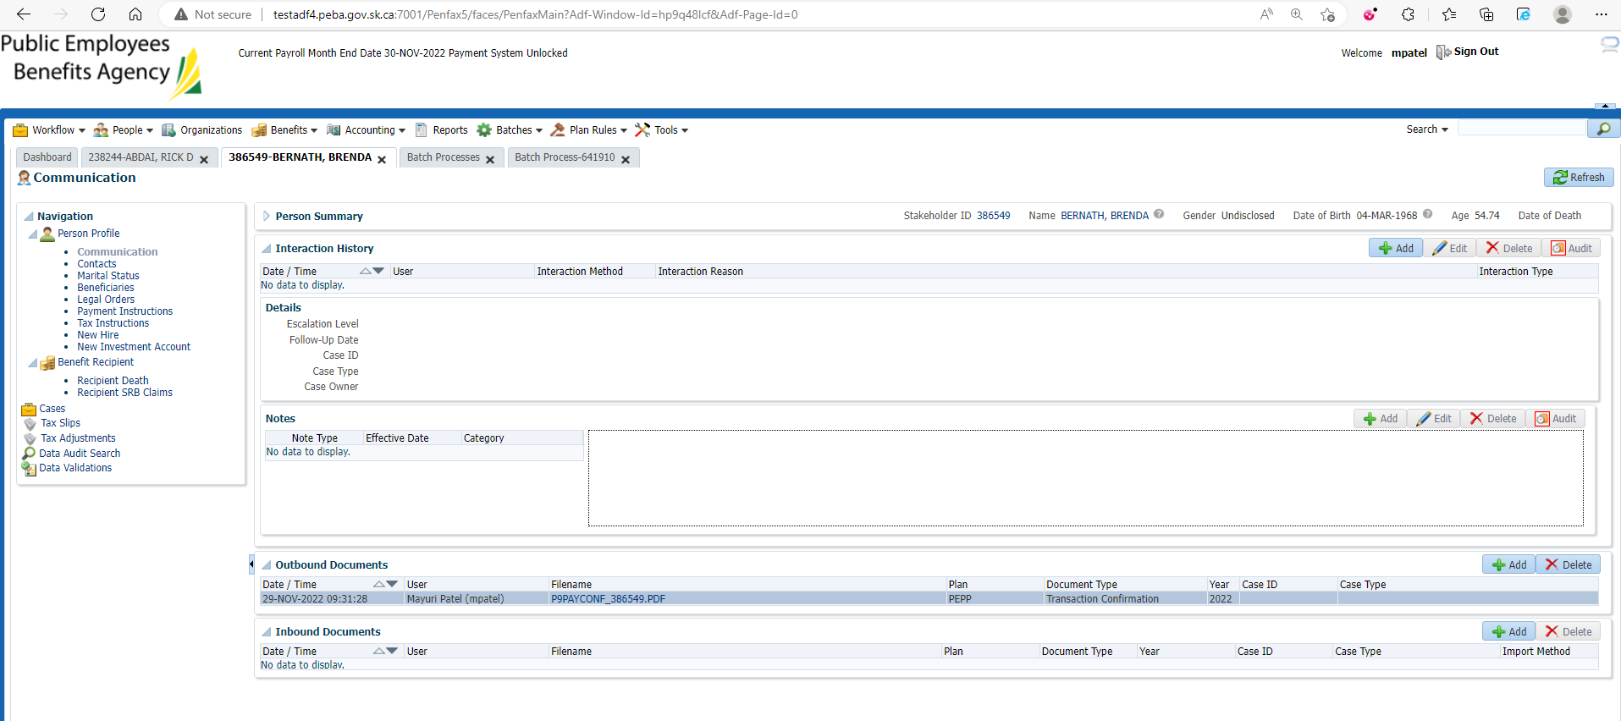

PEPP Payment Confirmation Letter

